Editable poster


“Enabling educators to become aware of the real-life challenges faced by LGBTQIA+ learners and leading the educators towards setting personal learning objectives for improved inclusion.”

The purpose of this tool is to communicate to students, staff, and stakeholders of the training institution that it supports the LGBTQIA+ community.
The poster can be customized by inserting the logo and name of the institution and the name and contact information of the anti-bullying contact person.
The advice is to hang this poster in transit locations where it can be seen by as many people as possible.



Funded by the European Union. Views and opinions expressed are however those of the author(s) only and do not necessarily reflect those of the European Union or the European Education and Culture Executive Agency (EACEA). Neither the European Union nor EACEA can be held responsible for them.

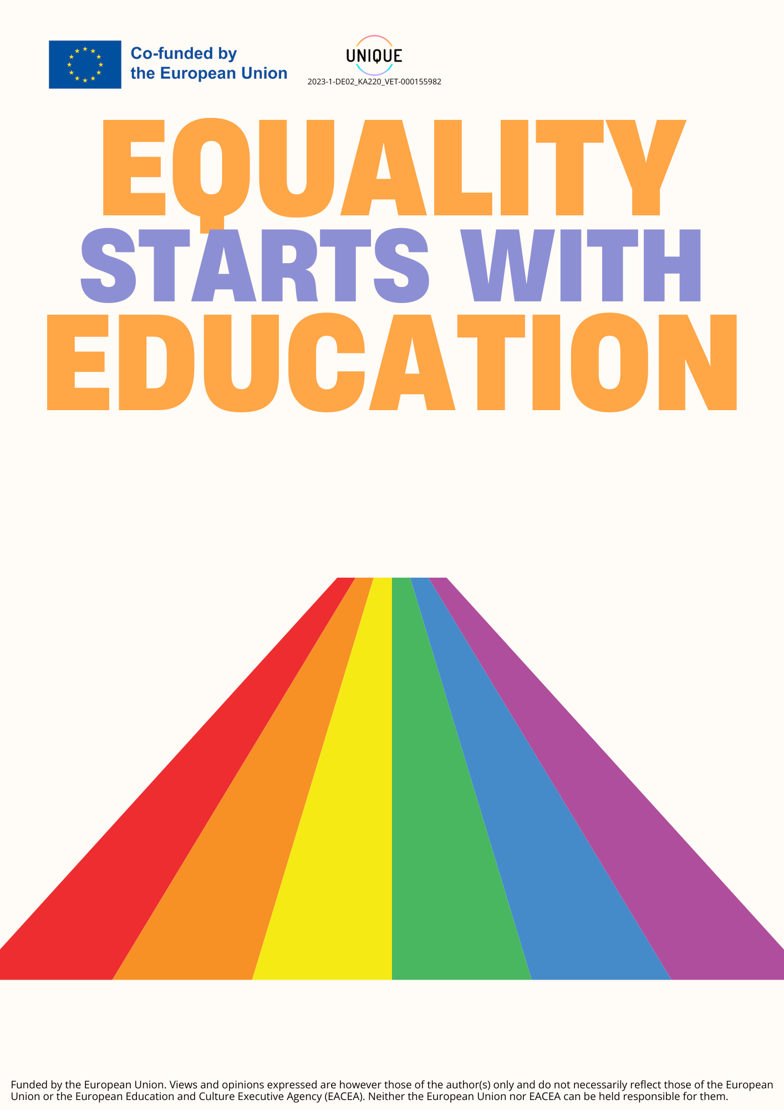
[Name of the institution] promotes inclusion and respect for you, regardless of your gender and sexual orientation.
If you've experienced or witnessed abuse, report it!
[Name of reference person] | [contacts]

[Institution logo]

