Registration form
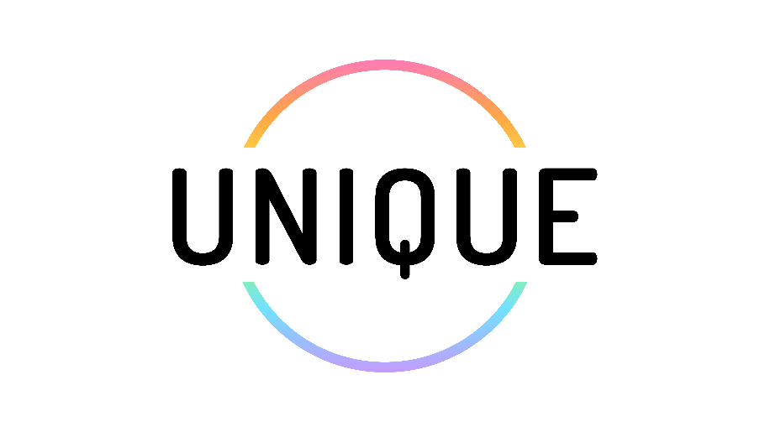

“Enabling educators to become aware of the real-life challenges faced by LGBTQIA+ learners and leading the educators towards setting personal learning objectives for improved inclusion.”

It allows to obtain essential data on participants, such as their name, position, contact details, and any other information relevant to the workshop.

Registration form for the UNIQUE training course

This is a customisable registration form template. Customise it with the necessary fields. Make a copy and add specific workshop/training details, such as dates, times, locations or requirements, as needed.

We are pleased to invite you to a workshop that introduces practical tools and personalised learning pathways to promote inclusivity for LGBTQIA+ learners within educational institutions.
Date:
Time:
Venue:

Name & Surname:
Email:
Organisation:

What days will you attend?
- Day 1
- Day 2
- Day 3

Dietary restrictions
- None
- Vegetarian
- Vegan
- Kosher
- Gluten-free
- Others:

I understand that my data will only be used for this purpose of the project.
- Yes

